Janeka Martin
MKN1 — MKN1 Task 1: Relational Database Design and Implementation
Data Management — D597
Part 1: Design Document

A. Select one of the provided scenarios to complete the following:
- Describe a business problem that can be solved with a database solution and is in alignment with the chosen scenario.

HealthFit Innovations specializes in technological solutions for improving patient health care. Their newly developed platform, HealthTrack, collects patient and fitness tracker details from various health platforms, including wearable fitness trackers, health records, image systems, and patient-reported outcomes. HealthFit Innovations needs a consistent way to store patient and the trackers’ data, as the data is complex and challenging to integrate and query quickly. Currently, the company does not have a relational database to store the various amounts of data received. Due to the inability to store the data, stakeholders cannot analyze data efficiently and make informed business decisions to market products properly. To address this issue, HealthFit needs a relational database to consolidate various data sources and enable readily available data for analytics to inform future product decisions.

- Propose a data structure to solve the identified business problem.

To organize HealthFit’s data and support analysis, an Entity-Relationship Model (ER Model is the most appropriate approach to solve the business problem. The ER model provides a blueprint for normalized relational tables, reduces redundancy, and enables efficient and accurate queries to answer business questions (GeeksforGeeks, 2025). Once the ER Model is established, implementing a Relational Database Management System (RDBMS) such as PostgreSQL allows the ability to enforce keys and constraints, define data types, and add indexes for performance. PostgreSQL is open-source, free to use, and flexible enough to handle complex data needs (LinkedIn Learning, n.d.). Using pgAdmin, the user interface for PostgreSQL, schemas can be created, ERD visualized, import data, manage permissions, and run/explain queries LinkedIn Learning, n.d.). PostgreSQL and pgAdmin translate the ER model into a secure, scalable solution that integrates patient and device data and supports timely, trustworthy decision-making analytics.

- Justify why a database solution will solve the identified business problem.

A relational database solution designed with an ER model and implemented in PostgreSQL will solve HealthFit’s challenges to store and unify complex patient and device data to allow quick and consistent querying (pgAdmin Development Team, 2025). Using pgAdmin will provide an accessible interface to load data, define constraints, and run/explain queries to make data readily available for analysis, making the system easy to operate and deliver timely insights for care and product decisions instead of spending time stitching data together. HealthFit can leverage stored data to analyze and answer business objectives using these programs.

Functional Requirements: The database solution ingests patient and device data from multiple sources (wearable devices, electronic health records (EHRs), medical imaging systems, and patient-reported outcomes) through repeatable and straightforward loads to store data. The PostgreSQL platform can easily retrieve data fast, providing timely business insights. Furthermore, pgAdmin offers an accessible interface to create schemas, import data, run/explain queries, and manage permissions LinkedIn Learning, n.d.). This solution can also provide read-only views to expose only the fields needed for analysis, supporting a secure solution.

Non-functional Requirements: The database must be performant and scalable, using appropriate data types and indexes to better handle the pace of the growing volume of data. It must ensure integrity with constraints and referential rules, protect privacy via role-based access, and provide privilege permissions to ensure the safety of patient data.

- Explain how the business data will be used within the database solution.
HealthFits’ data will be loaded into tables using PostgreSQL/pgAdmins. An ER model will be created to identify relationships, and primary/foreign key constraints will also be applied to support fast retrieval as the data grows (LinkedIn Learning, n.d.).

Once loaded, users will access the database through standard SQL via PostgreSQL or pgAdmin’s interface to answer business questions. Read-only views expose only the fields needed for analysis to protect sensitive patient data. Typical analyses include identifying patients’ most used tracker models, examining whether a correlation exists between device ratings and medical appointments, and understanding whether allergies drive device sales.

B. Create a logical data model for storing data in the database solution.
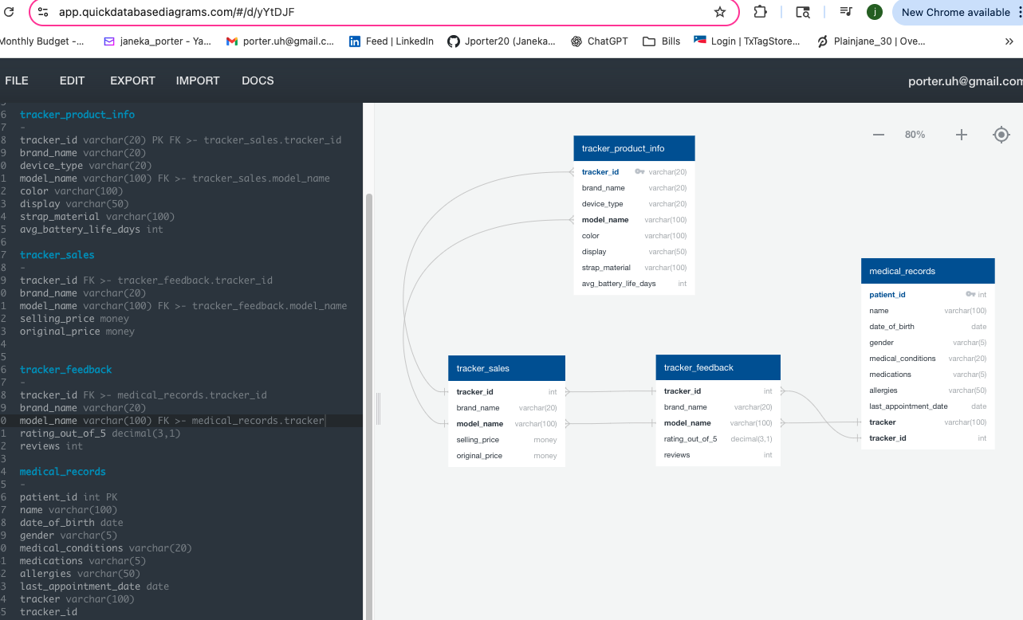
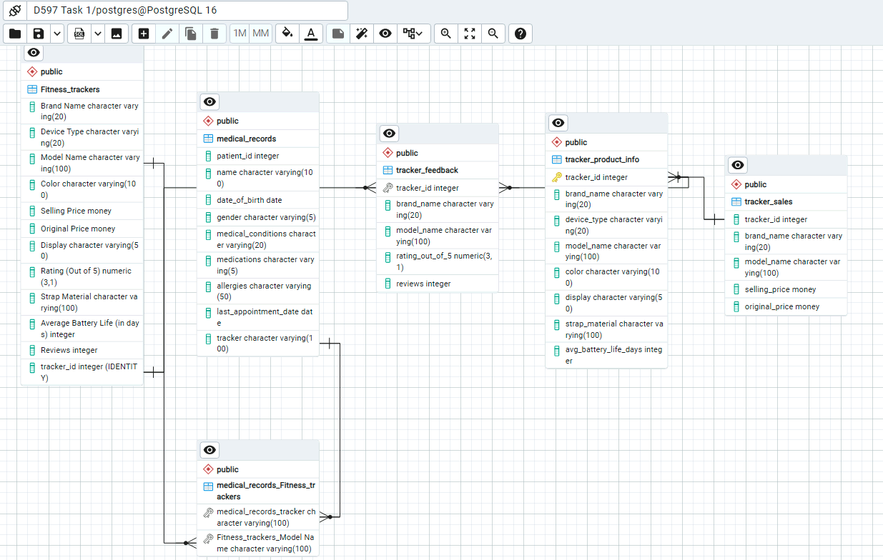

C. Describe the database objects and storage, identifying the file attributes within the database solution.
The source files Fitness_Trackers and medical_records are first loaded into staging tables, then inserted into normalized target tables.
- Tracker_product_info
Purpose: one row per model, used as the parent for sales/feedback and to link patients to a model.
  - Columns (attributes) – Tracker_ID PK, Brand Name, Device Type, Model Name, Color, Display, Strap metal, Avg Battery Life (in days)
- Tracker_sales
Purpose: holds data for pricing for each model and sales
  - Columns (attributes) – Tracker_ID FK, Brand Name, Model Name, Selling Price, Original Price
  - This table connects to Tracker_product_info.
- Tracker_feedback
Purpose: holds data for patient tracker rating and reviews
  - Columns (attributes) – Tracker_ID FK, Brand Name, Model Name, Rating (Out of 5), Reviews
  - This table connects to Tracker_product_info.
- Medical_records
Purpose: holds data for patients and their current trackers
  - Columns (attributes) – patient_id PK, name, date_of_birth, gender,medical_conditions, medications, allergies, last_appointment_date, tracker, tracker_id FK
  - This table connects to Tracker_product_info.
D. Discuss how the proposed database design addresses scalability concerns, including strategies that align with the chosen scenario.
This proposed database design addresses scalability concerns as the model keeps device data centralized and sensitive patient data separated. This model avoids duplication and keeps tables smaller and faster to scan as volume increases. Each table enforces primary and foreign keys and adds indexes on common joins and filters (i.e., Model Name, tracker_id, and patient_id) so queries remain quick even as rows multiply.
E. Outline the privacy and security measures that should be implemented in the proposed database design.
To protect sensitive patient data in the proposed PostgreSQL design, role-based privilege access should be used so analysts only get read-only roles to query, while ETL/admin roles handle loads and updates (LinkedIn Learning, 2024). Sensitive patient data is separated and exposed through limited access to view only the required fields. Additionally, regular backups and access reviews can ensure the design remains secure and compliant. Implementing these security measures provides a secure database design while providing trustworthy analytics.

Part 2: Implementation
Note: The data files for each scenario are located in a folder titled “D597 Datasets” on the desktop of the WGU Virtual Lab environment. Be sure to pull the files from “Task 1” that relate to your chosen scenario.

Note: Submit your screenshots showing the successfully run queries from the WGU Virtual Lab for each prompt with your design document.

F. Implement the proposed database design in the WGU Virtual Lab environment by completing the following:
- Write script to create a database instance named “D597 Task 1” using the appropriate query language, based on the logical data model in part B. Provide a screenshot showing the script and the database instance in the platform.

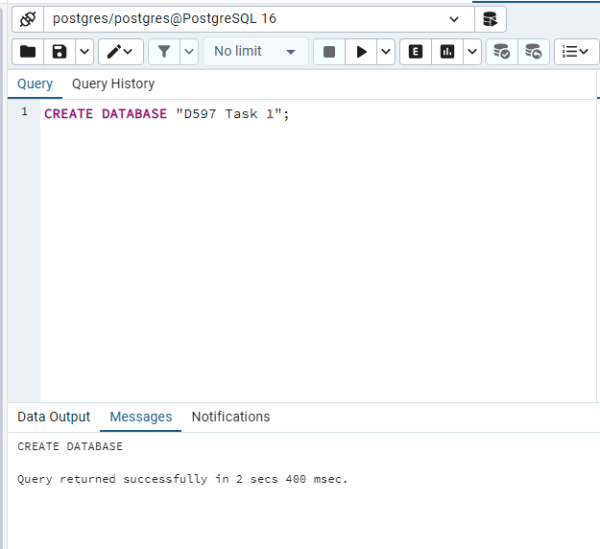

- Write script to import the data records from the chosen scenario CSV files into the database instance. Provide a screenshot showing the script and the data correctly inserted or mapped into the database.
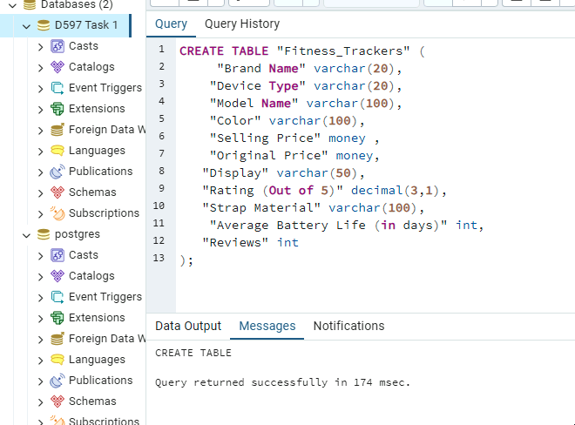
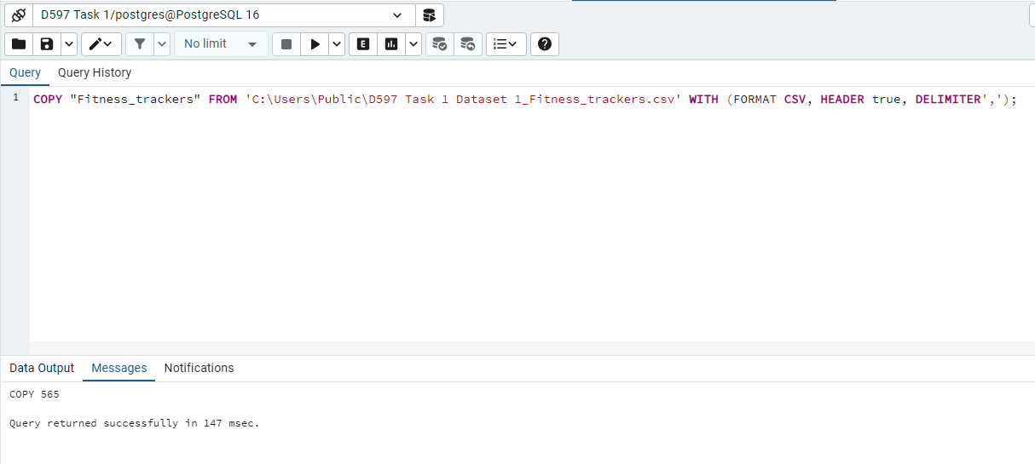
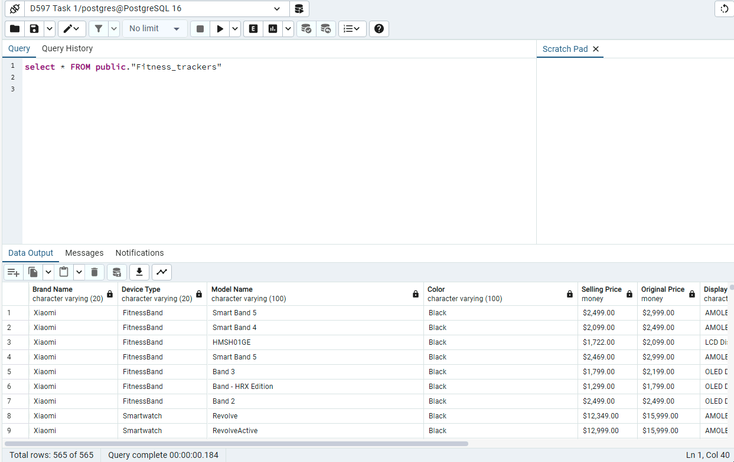
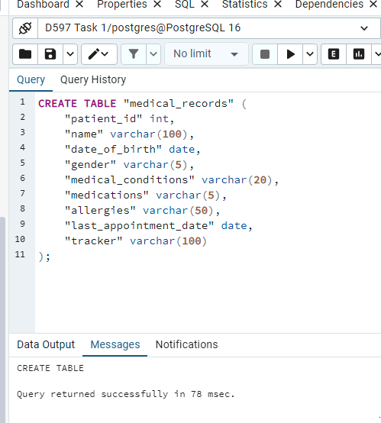
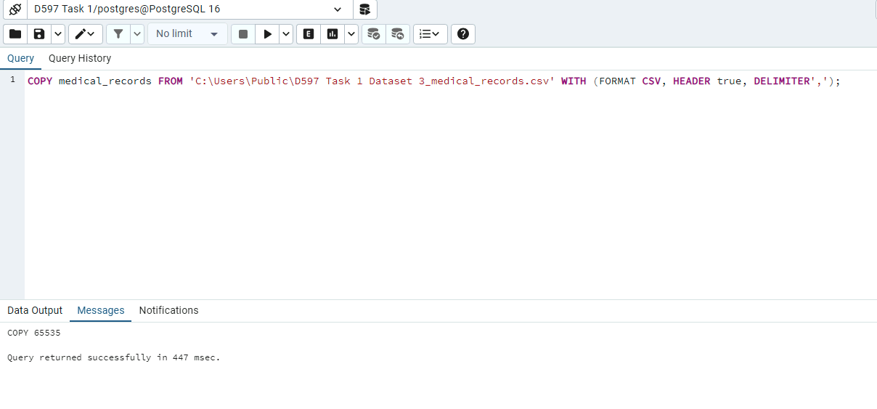
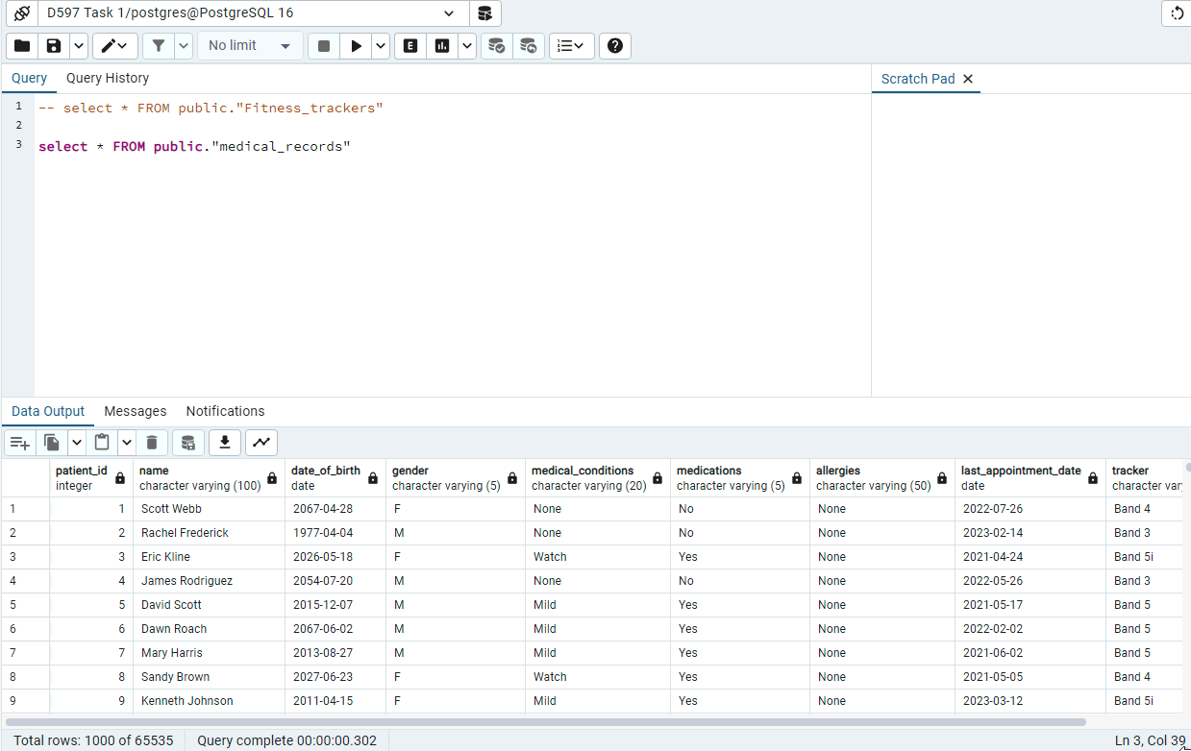

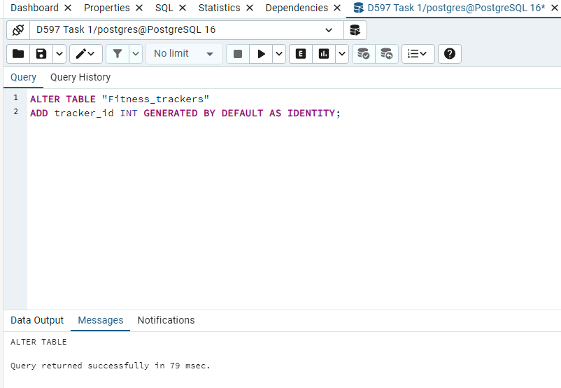
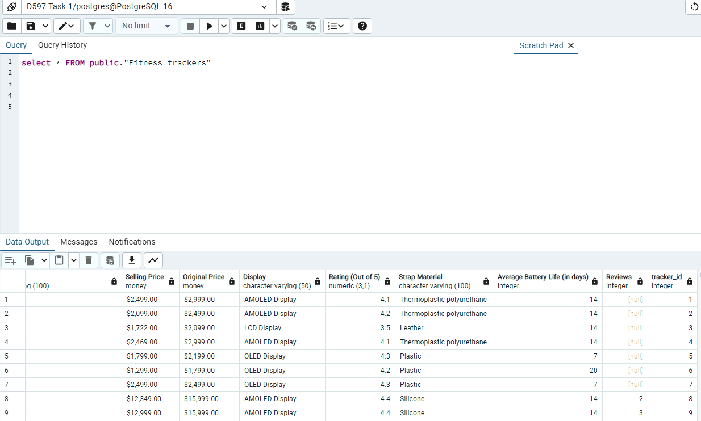
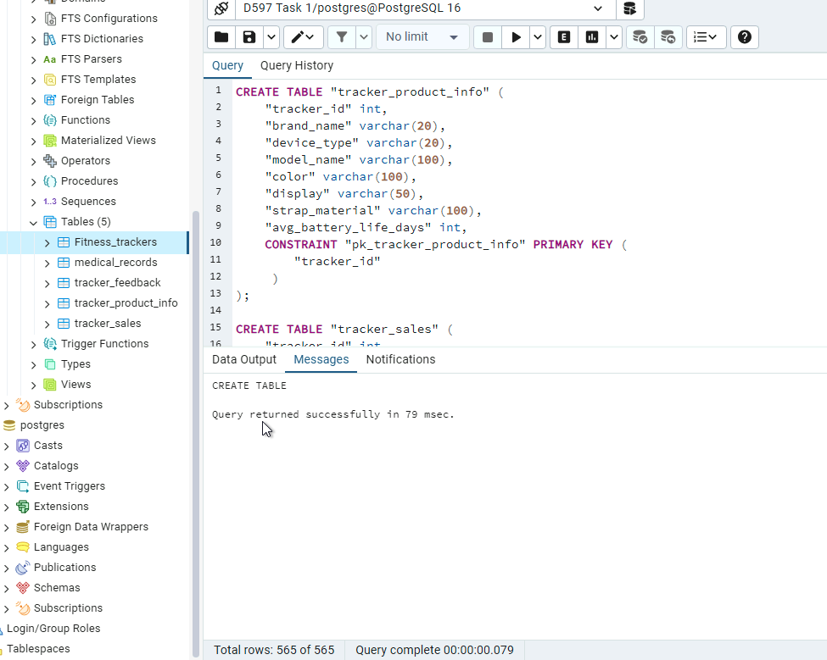
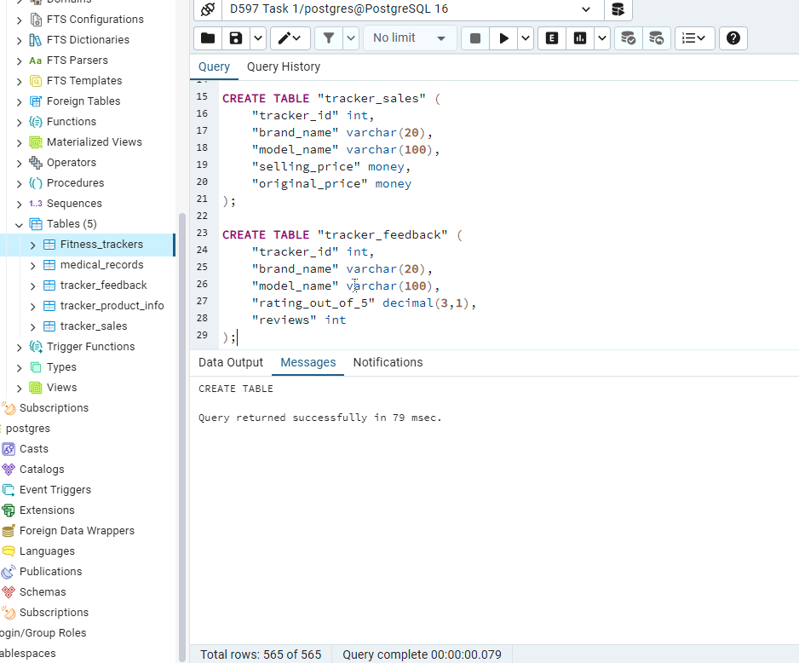
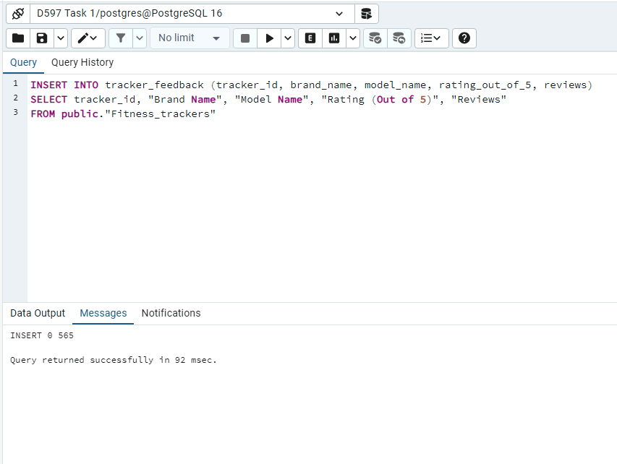
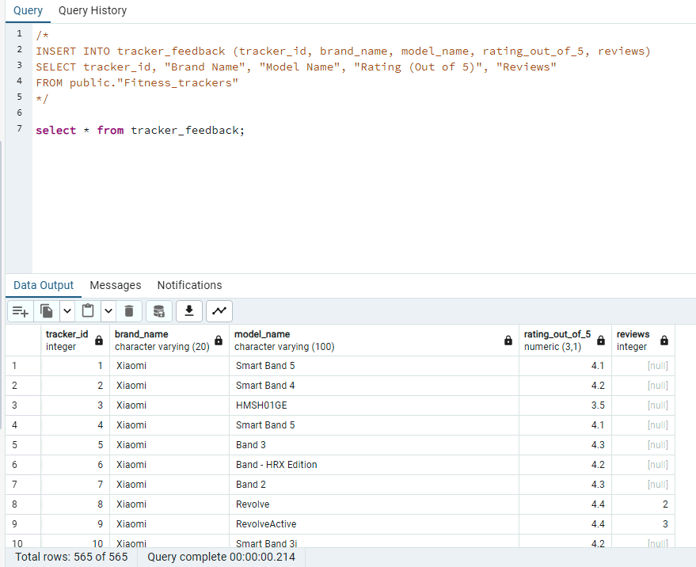
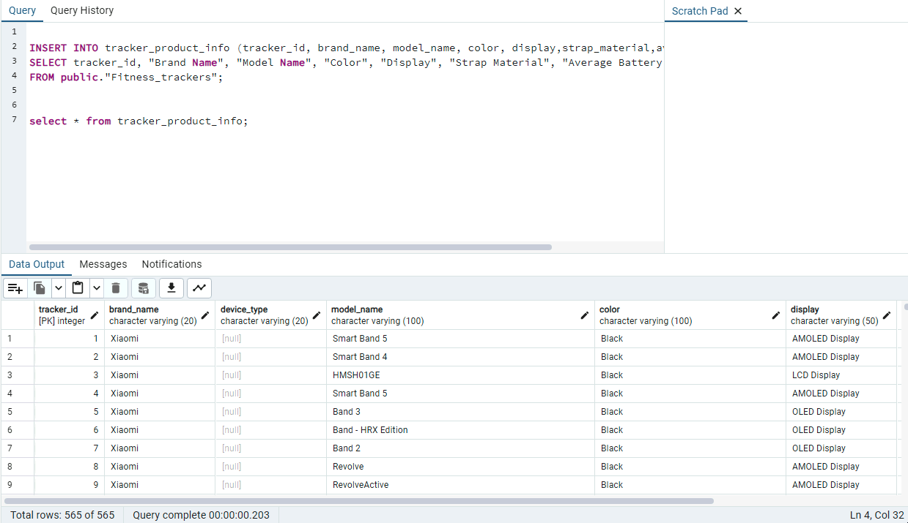
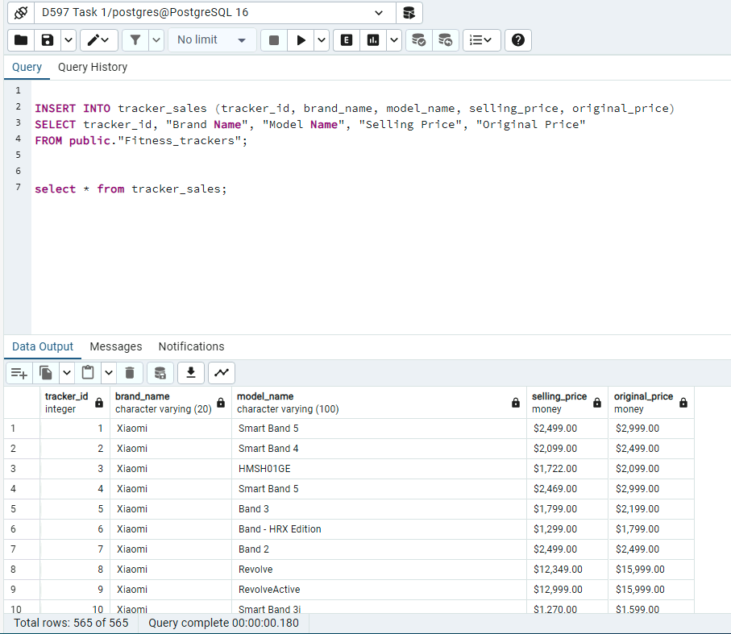

- Write script for three queries to retrieve specific information from the database that will help to solve the identified business problem. Provide a screenshot showing the script for each query and each query successfully executed.

Business value: Reveals which devices are the most popular amongst patients.

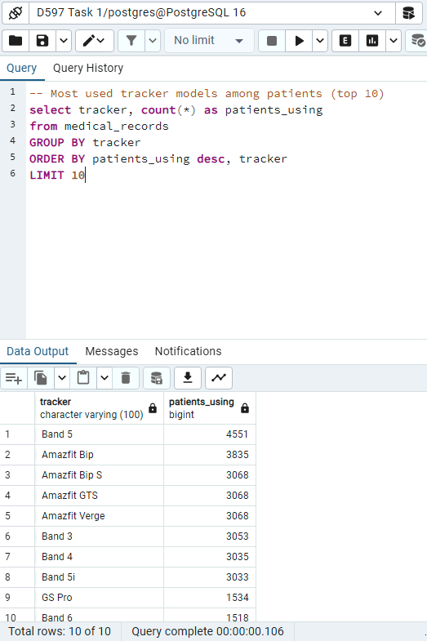
Business value: Provides insights on whether allergies are the main driver for top selling trackers

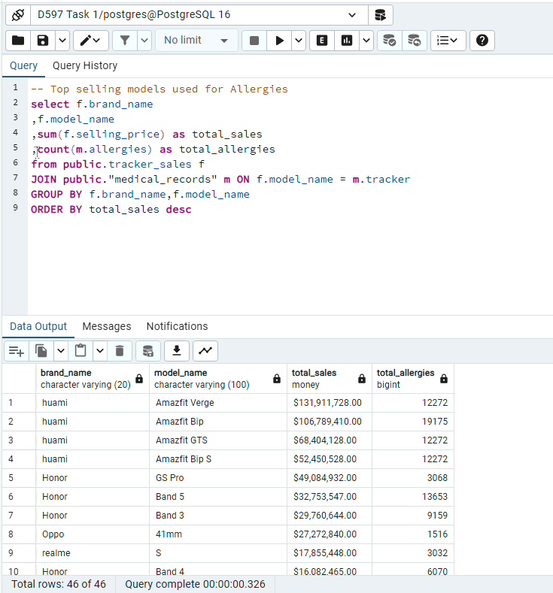

Business value: Shows whether higher rated tracker devices prove more appointment engagement
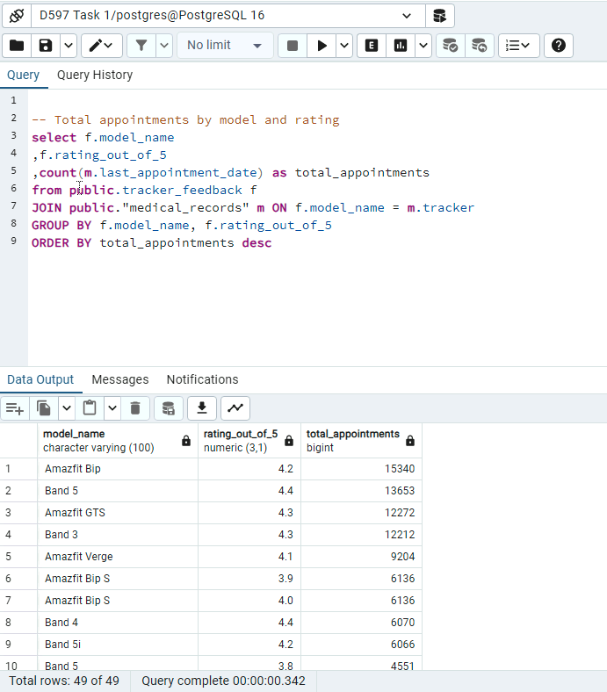
- Apply optimization techniques to improve the run time of your queries from part F3, providing output results via a screenshot.
Previous runs:
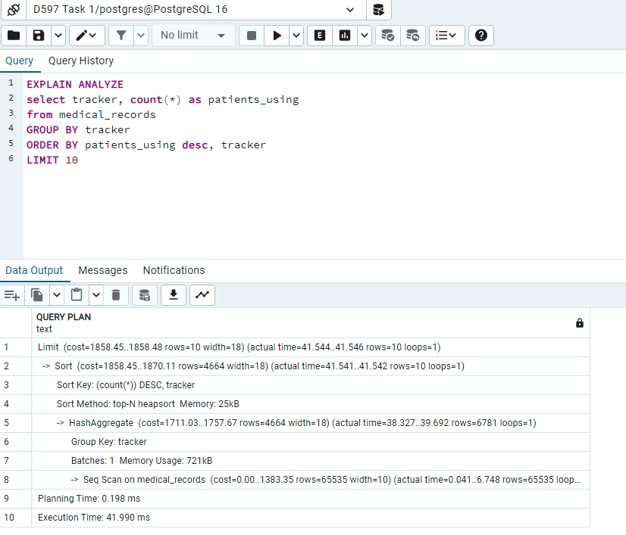
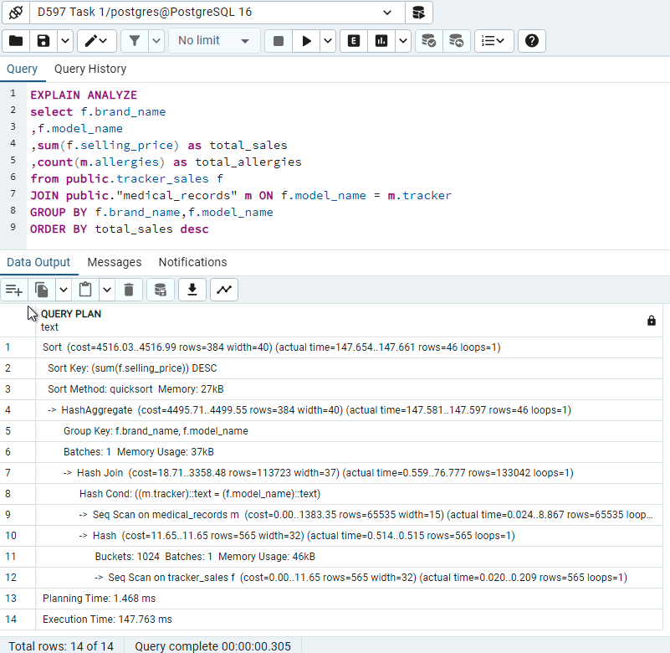

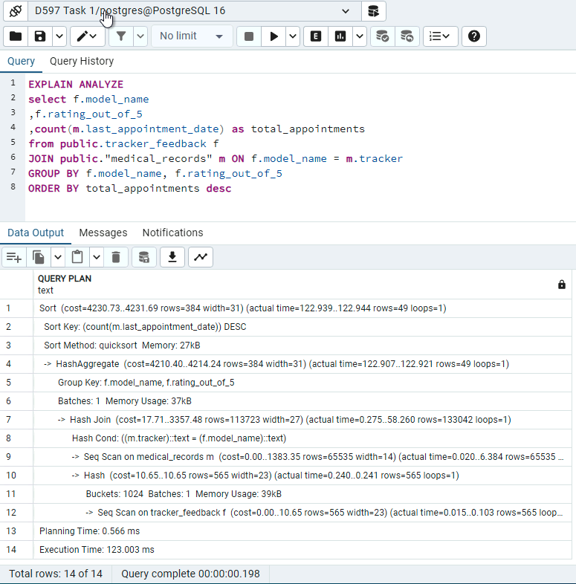
Runs with Indexes:
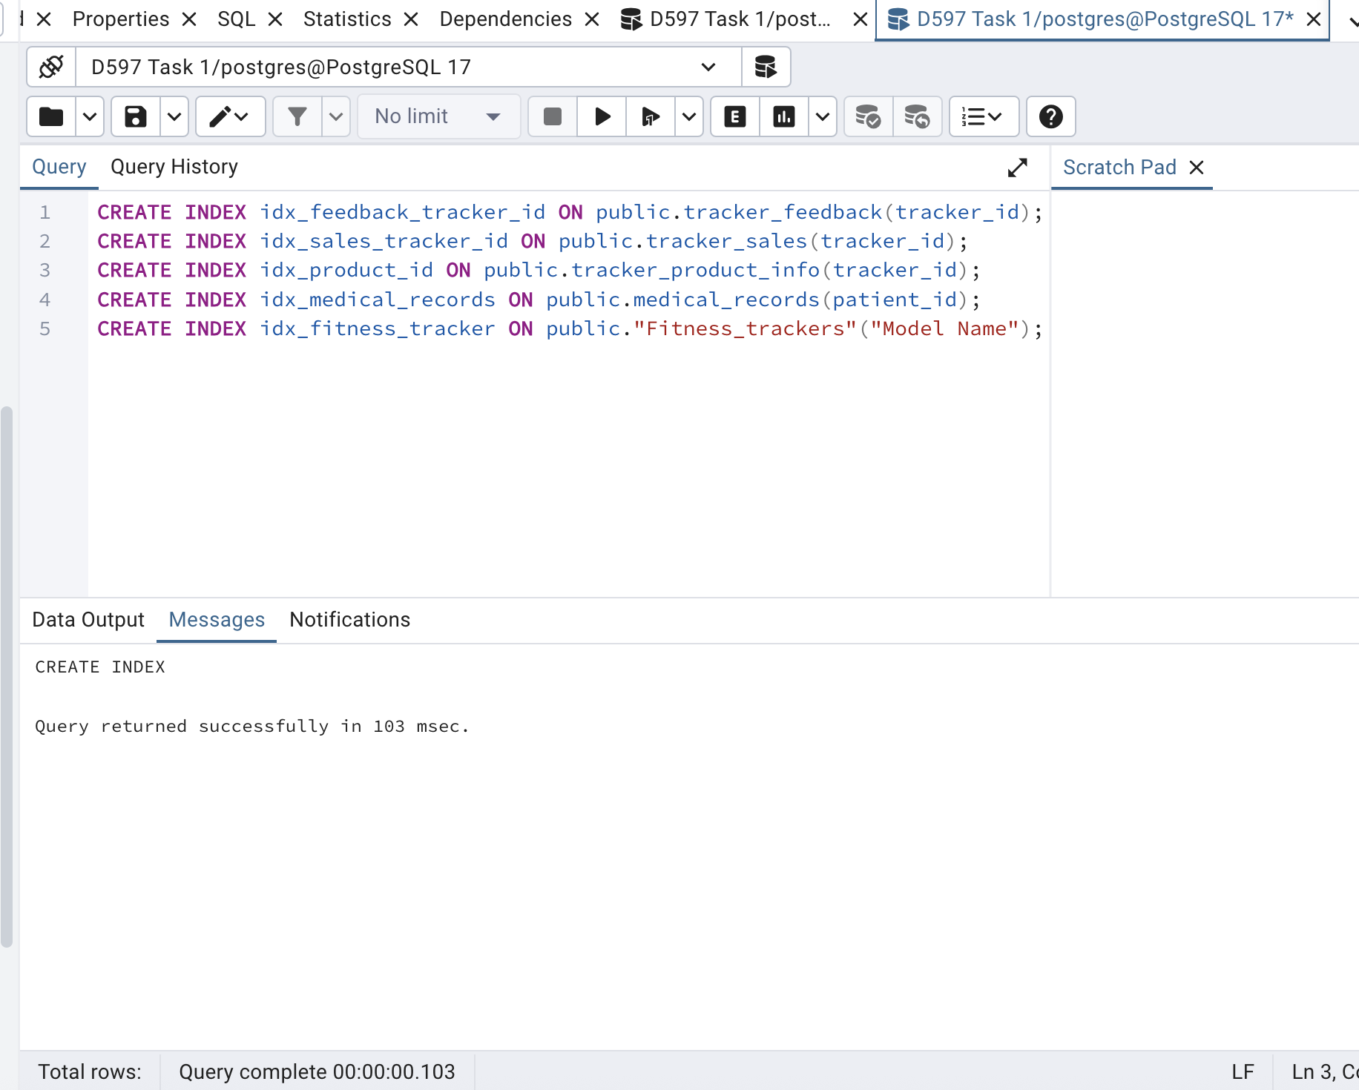

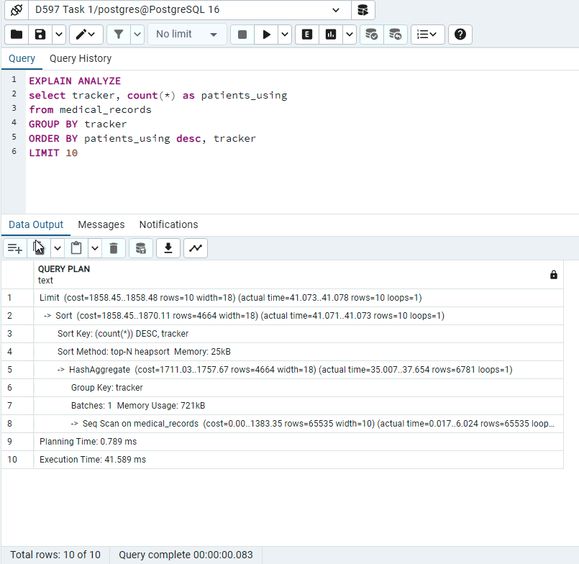
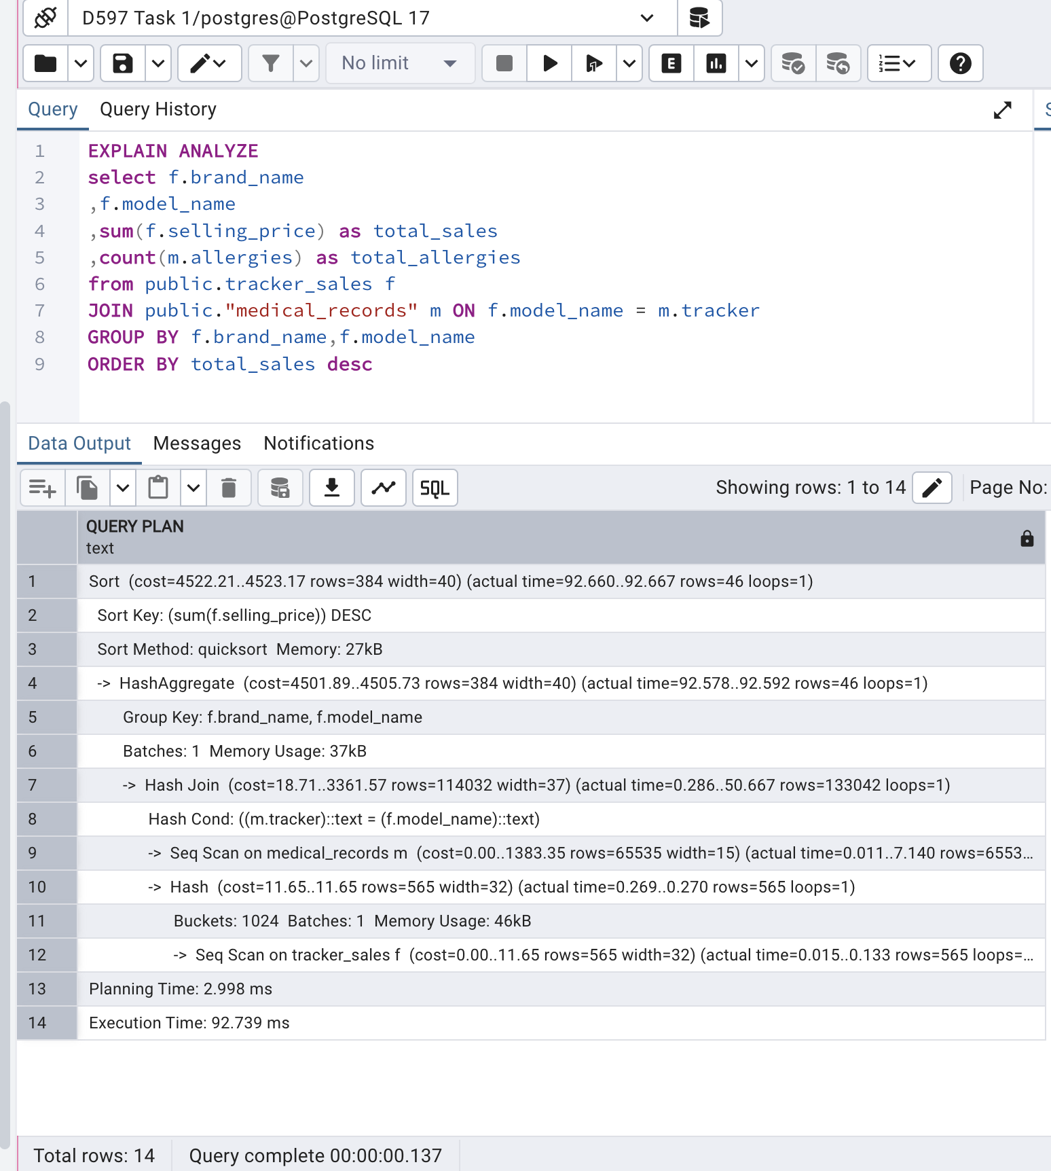
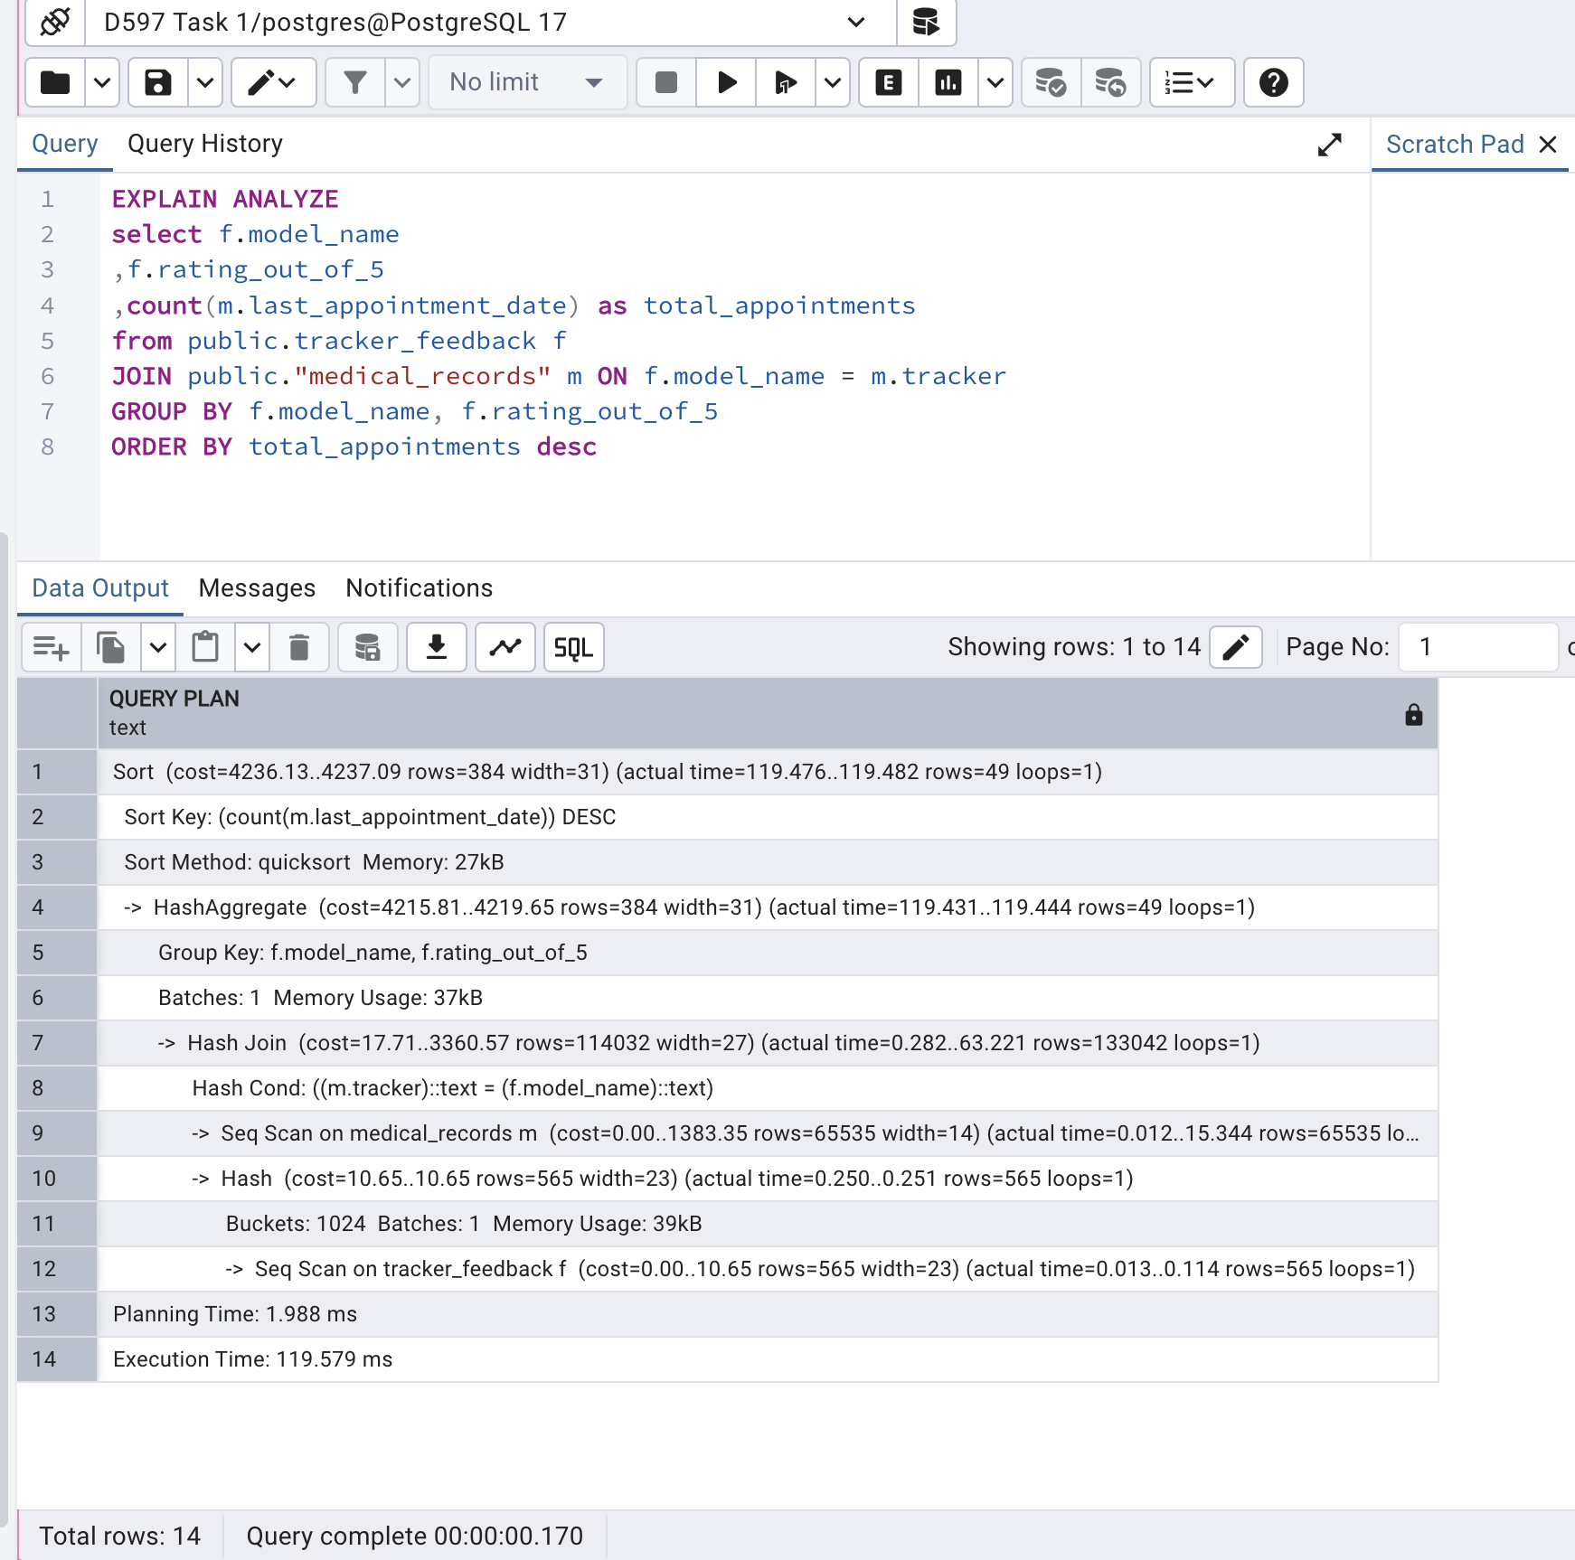

Sources
GeeksforGeeks. (2025, September 9) Introduction of E-R model.
https://www.geeksforgeeks.org/dbms/introduction-of-er-model/

LinkedIn Learning. (n.d.). Relational Database Essential Training: Relational database normal forms [Video].LinkedIn Learning https://www.linkedin.com/learning/relational-databases-essential-training/relational-database-normal-forms?autoSkip=true&resume=false&u=2045532

LinkedIn Learning. (n.d.). Database Foundations: Data Structures – Purpose of a primary key [Video].LinkedIn Learning https://www.linkedin.com/learning/database-foundations-data-structures/purpose-of-a-primary-key?resume=false&u=2045532
pgAdmin Development Team. (2025). ERD Tool – pgAdmin 4 (Version 9.8) documentation. https://www.pgadmin.org/docs/pgadmin4/9.8/erd_tool.html
LinkedIn Learning. (n.d.). Postgre Essential Training: Manage relational data with PostgreSQL [Video].LinkedIn Learning https://www.linkedin.com/learning/postgresql-essential-training-22611610/manage-relational-data-with-postgresql?u=2045532
LinkedIn Learning. (2024, June 3). Complete Guide to SQL for Data Engineering: Introduction to database security[Video].LinkedIn Learning https://www.linkedin.com/learning/complete-guide-to-sql-for-data-engineering-from-beginner-to-advanced/introduction-to-database-security?u=2045532

